..,

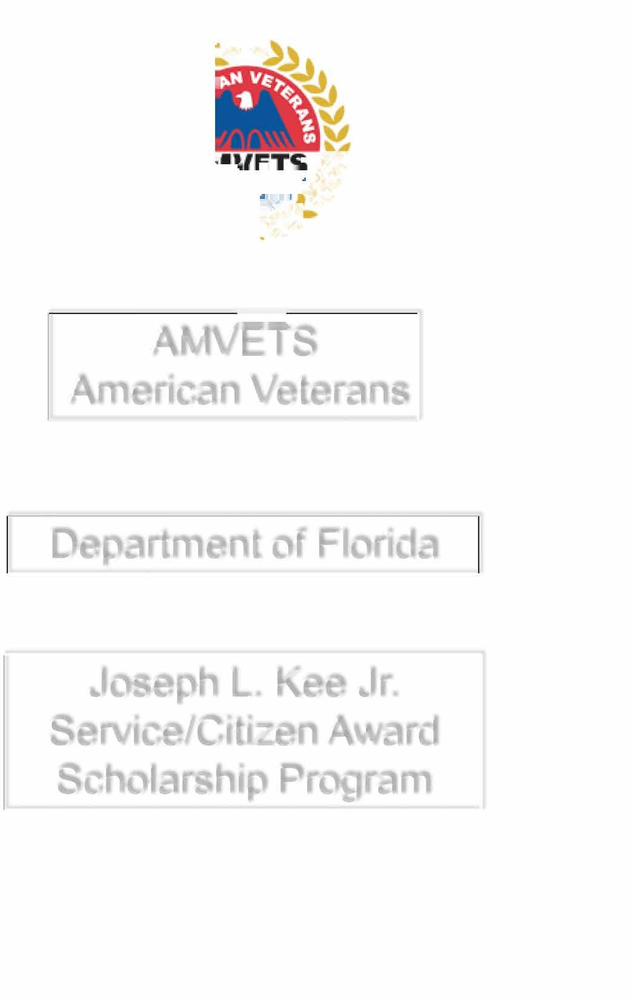

.· � ***.***

**.....�,**

-

# AMVETS

American Veterans

# Department of Florida

Joseph L. Kee Jr.

Service/Citizen Award Scholarship Program

## Authorization to Release Information

I hereby authorize the Department of Florida AMVETS obtain release to the following:

Name: Address:

The documents to be released are described or listed as:

1. High School Academic Record/Report Card
2. Address
3. SSN
4. Date of Birth
5. Letters of recommendations
6. Family Financial Status
7. Copy of Free Application for Federal Student Aid (FAFSA)
8. Copy of DD-214
9. Copy of AMVETS current membership card

The records are required for the specific purpose of: Joseph L. Kee Jr. Service/Citizen Award

I understand that my authorization will remain effective from the date of my signature until 31 Dec 2025, and that the information will be handled confidentially in compliance with all applicable federal laws.

I understand that this scholarship is awarded after June 2025.

I may see the information that is to be sent, and that I may revoke the authorization at any time by written, dated communication.

I have read and understand the nature of this release.

Signature: Date:

PRIVACY ACT PROTECTED: This electronic transmission contains information which must be protected under the Privacy Act of 1974 (see 5U.S.C 552a). Do not release outside of AMVETS channels without the consent of the originator's office unless specifically authorized by the Privacy Act. This information is also exempt from disclosure under exemption 6 of the Freedom of Information Act, 5 U.S.C

552. If the reader of this message is not the intended recipient, or an employee or agent responsible for delivering this message to the intended recipient, you are hereby notified that dissemination, distribution or copying of this communication is strictly prohibited.

AMVETS DEPARTMENT OF FLORIDA SERVICE FOUNDATION SCHOLARSHIP APPLICATION.

## The Joseph L. Kee Jr. Service/Citizen Award

The AMVETS Service Foundation Scholarship has been established to recognize students who can provide evidence of volunteer service to their community. Scholarships will be judged at the AMVETS Spring Budget Meeting. A possible total of four (4) scholarships may be awarded at the Florida State Convention.

## ELIGIBILITY:

The applicant must be a member of the Department of Florida AMVETS, Ladies Auxiliary, son/daughter, grandchild, and or great grandchild of a member of Department of Florida AMVETS, AMVETS Ladies Auxiliary or Sons of AMVETS. Be a graduating high school senior or a student attending a vocational school community college or university.

## REQUIREMENTS:

The applicant must submit an essay of not more than 500 words and not less than 300 words. It should include past accomplishments, educational goals and why volunteering is important.

Applicants must provide proof of acceptance to a vocational school, community college or university. The applicant must submit at least one (1) letter of recommendation that includes proof of volunteering (excluding family members).

The applicant must include proof of eligibility (copy of AMVETS or AMVETS Ladies Auxiliary membership card).

Application must be complete.

Sign copy of the Privacy Act/Authorization to Release Information Form.

## APPLICATION PROCESS:

Application must be received no later than April 30, 2025. Please make sure that all required materials are attached.

SEND APPLICATION TO:

AMVETS DEPARTMENT OF FLORIDA SERVICE FOUNDATION

PDC A. J. JOHN, VICE PRESIDENT

2780 CABERNET CIR

OCOEE, FL 34761-5044

407-766-7515

AMVETS DEPARTMENT OF FLORIDA SERVICE FOUNDATION SCHOLARSH APPLICATION JOSEPH L. KEE JR. SERVICE/CITIZEN AWARD

**Name: (Last) (First) (MI)**

**Telephone number: ( ) Email:**

**Address:**

**(City) (State) (Zip Code) List High School, vocational school, college or university attending: Address:**

**(Street) (City) (State) (Zip Code)**

**Address:**

**(Street) (City) (State) (Zip Code)**

**Address:**

**(Street) (City) (State) (Zip Code)**

**List the location, telephone number and the most recent date(s) of volunteering:**

**Organization Telephone Number Date(s)**

**List high school, vocational school, college, university and/or community activities participated in. Include offices held and awards received. (Use another sheet if needed)**

**Please specify what the scholarship money will be used for if awarded to you.**

**Certification: I/We certify that all information on this application is true, complete and accurate to the best of my/our knowledge. I/We agree to provide, if requested, any other documentation necessary to verify information reported. Any false information will be cause for denial or withdrawal of the scholarship offered.**

**(Applicants Signature) (Date)**

**(Parent/Guardian Signature if under 18) (Date)**

**AMVETS DEPARTMENT OF FLORIDA SERVICE FOUNDATION SCHOLARSHIP JOSEPH L. KEE JR. SERVICE/CITIZEN AWARD**

**Please send my scholarship award to:**

|  |  |  |
| --- | --- | --- |
| **(Applicant Name)**  **School Address:** |  | **(Vocational School/College/University)** |
| **(Street)** | **(City)** | **(State) (Zip Code)** |

**Name: (Last) (First) (MI)**

**Telephone number:**

**Address:**

**(City) (State) (Zip Code)**