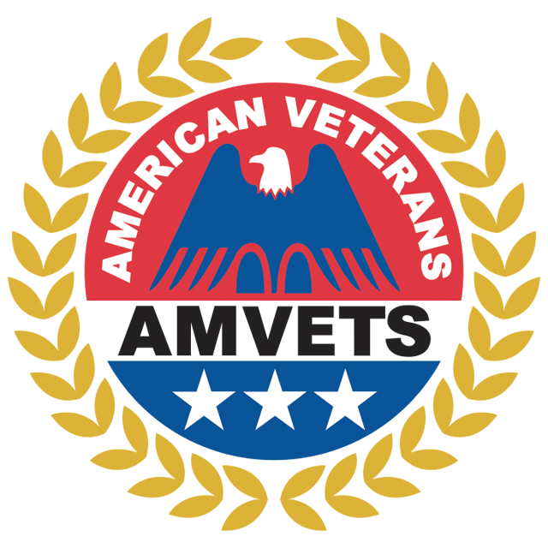
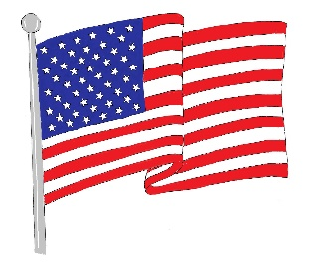
AMVETS Department of Florida
Honors and Awards Chairman
PDC Doug Furgeson,
2939 Sunway Ln.
Lakeland, Fl. 33801
863-777-0938
dougfurgeson@yahoo.com

Fellow AMVET Leaders,

At this time we need to start to consider nominating AMVETS who have served our Posts, Districts, and Department and who have served to contribute to the success of AMVETS.

Our Geen Hat program awards Post members who have only worn a Green Hat for their contributions to their post. A post may nominate more than one member, however only one will receive the Green Hat award. The Honors and Awards Committee will select one for every post that submits a Green Hat Nominee to receive the award. This nominee must not have worn any other hat, past or present.

The Honors and Awards program will be considering nominations for the 2025 year, beginning February 2025 and ending February 2026. We will be requesting the District Commanders to assist your posts.

The packets are attached to this letter along with the instructions. Look the categories over and confer with your members for nominees. Please fill all the categories that you have members eligible for. Volunteers get very little thanks for what they do and this gives you the chance to see that they are awarded.

Please make this a successful Honors & Awards year and those who are nominated, if selected, will receive their awards at the June 2026 Annual Convention. If you have questions my info is on the Letterhead. Send all packages to me at the email address listed above. Thanks!

PDC Doug Furgeson,
Honors & Awards Committee Chair

